MIT World Peace University, Pune
School of Computer Science & Engineering

Mini Project Report
Foundations of Programming — CSE10010
Asteroid Shooter
A Console-Based Action Game in C
Team Members:

Mehek Parekh -1262253185
Aarush Verma- 1262252580
Arnav Gupta- 1262252857
Hardi Patel- 1262251726
Indrayani Deshmukh- 1262253151

Project Guide:
- Dr. Renuka Mane

Table of Contents
1. Acknowledgment 2
2. Abstract 2
3. Introduction 3
3.1 Problem Statement 3 3.2 Background 3 3.3 Objectives 3
4. System Design 4
4.1 Bounding Box Collision Logic 4 4.2 The Frame-Rate Controller 4 4.3 Procedural Spawn Generation 5 4.4 Data Structures: Parallel Arrays 5
5. Compilation & Platform Compatibility 6
5.1 Linux / macOS / WSL 6 5.2 Windows (Native) & Cross-Platform Portability 6
6. Implementation 7
6.1 Technical Environment 7 6.2 Key Algorithms 7
6.2.1 Non-Blocking Input (kbhit & getch) 8 6.2.2 Asteroid Variance & Chance System 8 6.3 Rendering Engine & ANSI Escape Codes 9
7. Results and Discussion 10
7.1 Data Types and Logic Functions 10 7.2 Performance Analysis 11 7.3 Testing and Quality Assurance (QA) 11
8. Conclusion and Future Scope . 12
8.1 Conclusion 12 8.2 Future Scope 12
9. References 13

1. Acknowledgment
We would like to express our sincere gratitude to our project guide, Dr. Renuka Mane, for providing continuous guidance and technical insights throughout the development of this project. Their help in understanding terminal-level I/O and non-blocking input was instrumental.
We are also thankful to the School of Computer Science & Engineering at MIT-WPU for providing the necessary infrastructure and a conducive learning environment. Finally, we thank our teammates for their collaborative efforts in coding, debugging, and documenting this game.

2. Abstract
This report details the design and implementation of Asteroid Shooter, a real-time, console-based action game developed in the C programming language. The project demonstrates advanced use of C standard libraries, system-level terminal manipulation, and game loop logic.
Key technical challenges addressed include implementing non-blocking keyboard input (kbhit), managing asynchronous object movement (asteroids vs. bullets), and rendering a dynamic ASCII-based interface. The game utilizes complex data structures like arrays for state management and employs procedural generation for asteroid types and spawn rates.

3. Introduction

3.1 Problem Statement

The objective is to create an interactive, real-time "Asteroid Shooter" game that runs in a standard terminal. The game must handle user input without pausing the program execution, manage multiple moving entities, and calculate collisions in a 2D-mapped 1D array space.

3.2 Background

Traditional beginner C programs are "stop-and-wait" (using scanf). However, game development requires a Game Loop architecture. This project moves beyond basic syntax to explore:
- Real-time system calls (termios.h, fcntl.h).
- Frame-based timing using usleep.
- ASCII art rendering and ANSI escape codes for screen clearing.

3.3 Objectives

- Develop a multi-lane survival game using C.
- Implement three distinct asteroid types with varying health, speed, and point values.
- Use struct termios to allow fluid player movement.
- Maintain a stable frame rate of 10 FPS (100ms delay).

4. System Design

4.1 Bounding Box Collision Logic

Unlike simpler games that check a single coordinate, this project implements Bounding Box Collision for multi-cell objects. Since Type 3 asteroids are 3 units tall, the code calculates the top and bottom of the asteroid relative to its current asteroidRow.
- Logic: A hit is registered if bulletRow is the asteroid's top and its bottom.
- Win/Loss Condition: Similarly, a "Game Over" occurs if the playerLane matches the asteroid's lane and the HEIGHT - 1 (player row) falls within that same vertical bound.

4.2 The Frame-Rate Controller
To ensure the game doesn't run too fast for a human to play, we use usleep(100000).
- Execution Frequency: This creates a delay of 100 milliseconds, resulting in a steady 10 Frames Per Second (FPS).
- Speed Variation: By using frame % moveRate == 0, we allow different asteroids to move at different speeds even though the global game loop runs at a constant rate.

5. Compilation & Platform Compatibility
Because your code uses <termios.h> and <fcntl.h>, it is designed for POSIX-compliant systems (Linux, macOS, or WSL on Windows).
5.1 Linux / macOS / WSL
To compile and run your project, use the standard GCC compiler:
Bash
gcc asteroid_shooter.c -o asteroid_shooter
./asteroid_shooter

5.2 Windows (Native)
The provided code will not compile natively on MinGW or MSVC because termios.h is not a standard Windows library.

6. Implementations
6.1 Technical Environment
- Language: C (C99 Standard)
- Compiler: GCC
- Operating System: Linux / macOS (due to termios.h and unistd.h dependencies).
- Terminal: Support for ANSI escape codes.

6.2 Key Algorithms
Non-Blocking Input (kbhit & getch)
Standard C input pauses the game. We use termios.h to disable "canonical mode" and "echo."
C
newt.c_lflag &= ~(ICANON | ECHO);
tcsetattr(STDIN_FILENO, TCSANOW, &newt);
This allows the game to check for a keypress and immediately continue if none is found.
Asteroid Variance
The game differentiates asteroids using a "Chance" system:
- Type 1 (o): 50% chance, 1 HP, Speed 2.
- Type 2 (O): 30% chance, 2 HP, Speed 3.
- Type 3 (@): 20% chance, 3 HP, Speed 4.

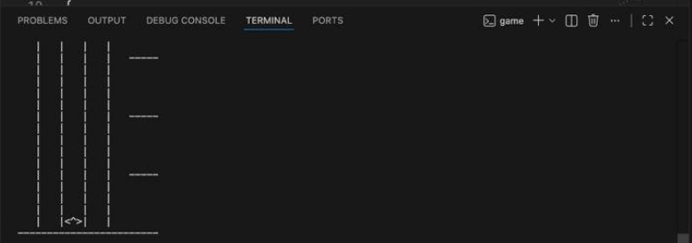

Here the output displays the 5 lanes that are available to the user and where the asteroids will fall from the top to bottom, along with the spacecraft (<^>) which is the player-controlled object in the game. As time progresses these lanes will be filled with asteroids of various sizes, falling from top to bottom. The output also displays a bottom (ground) line that is used to set a bottom limit to the playable space.

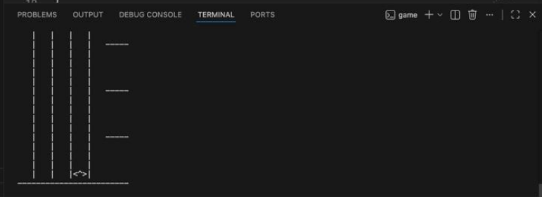

This image shows how the spacecraft (<^>) has moved to the right, lane 4, the same is achieved via the player inputting ‘D’ or ‘d’. The D key is used to move the spacecraft one lane right, while A key is used to move the spacecraft left.

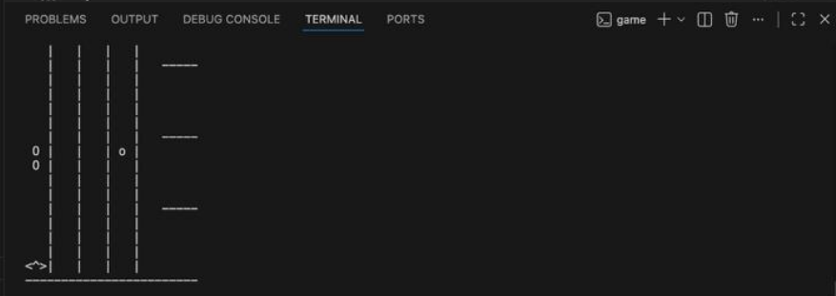

This image shows us how there are various types of asteroids that are falling from the top of the screen to the bottom, towards the player. The asteroids are the main way for the user to get points, if the player shoots the asteroid down then they receive points according to the asteroid that they blew up. Small asteroids are worth 1 point, Medium are worth 3 points and large ones are worth 5 points.

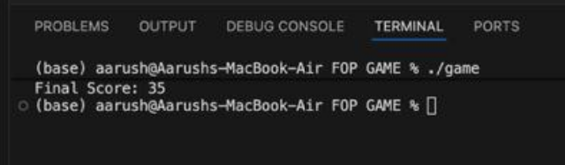

Here the final score of the user in the last session is displayed, the score is calculated based on the number of asteroids and types of asteroids destroyed by the player. The points earned from each asteroid are added and stored as a sum, which is changed again when a new asteroid has been destroyed. For example a player will have a score of 2 and once they destroyed a large asteroid their new score will change to 7 since a large asteroid is worth 5 points.
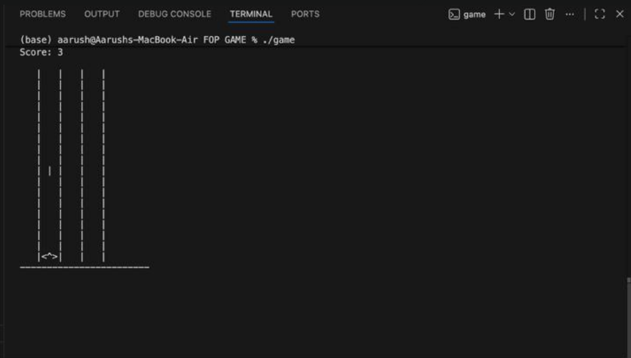

Here the user has shot a bullet, which is indicated by the vertical line that is moving upwards, the bullet moves closer to the asteroid due to them travelling in the opposite direction and explode the asteroid once the asteroids HP reaches zero. Each bullet deals damage of 1HP and can only be shot once per lane until the existing bullet in that lane has made contact.

Differences from Similar Games

Other games have a similar setup where they have a limited playing field in which asteroids are falling from the top and have to be shot down by the spacecraft for the player to earn points. So what sets us apart? The answer is unique asteroid characteristics. Our game features 3 types of asteroids, all with their unique traits. The small asteroid is worth 1 point and moves at a faster pace than others since it is only having 1HP thus allowing the user to shoot it down only with one bullet. Medium asteroids are the perfect balance, they move at a medium pace, are worth 3 points and are destroyed with 2 bullets. While large asteroids are the largest ones, they move at a very slow pace as it is difficult for the user to shoot this one down. It is difficult for the user to shoot it down since

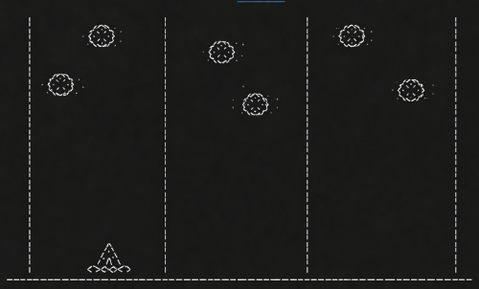

7. Results and Discussion
7.1 Data Types and Functions
Table 1: Game State Variables | Variable | Type | Purpose | | :--- | :--- | :--- | | asteroidRow[LANES] | int[] | Tracks vertical position of asteroids in each lane. | | bulletRow[LANES] | int[] | Tracks the position of the active projectile in each lane. | | playerLane | int | Current horizontal position of the ship (0-4). | | frame | int | Counter used to regulate speeds of different objects. |
Table 2: Logic Functions | Function | Purpose | | :--- | :--- | | asteroidSpeed() | Returns frame delay for movement; lower = faster. | | clearScreen() | Uses \033[H to reset cursor without flickering. | | usleep() | Controls the game speed (100,000 microseconds).

7.2 Analysis
The implementation successfully manages 5 lanes of traffic. By using usleep(100000), we achieved a consistent 10 FPS, which is responsive enough for a terminal game. The collision logic correctly handles "multi-cell" asteroids (Type 3) by calculating a top and bottom bound based on the asteroid type.

8. Conclusion and Future Scope
8.1 Conclusion
The Asteroid Shooter project successfully applies "Foundations of Programming" concepts to a complex, real-time environment. It demonstrates that C, despite being a low-level language, is highly capable of handling game logic, memory-efficient state management, and direct hardware-interface (terminal) manipulation.

8.2 Future Scope

- Power-ups: Adding items that clear all lanes or provide temporary invincibility.
- Multi-Bullet System: Currently, only one bullet per lane is allowed; an array-based bullet system would allow rapid fire.
- Color Support: Using ANSI color codes (e.g., \033[1;31m) to make asteroids red and the player green.
- Persistent High Scores: Writing the final score to a highscores.txt file.

9. References
- Kernighan, B. W., & Ritchie, D. M. (1988). The C Programming Language.
- IEEE POSIX Standard. termios.h - terminal control options.
- Advanced Linux Programming. Non-blocking I/O and fcntl.

